1. **IBM SPSS Modeler**
   1. Go here: <https://www.ibm.com/academic/home>and click register. Use this email address format when creating an account: [upi@aucklanduni.ac.nz.](mailto:upi@aucklanduni.ac.nz)
   2. After registering, log in and scroll down. Click on the Data Science → Software tab, then click SPSS Modeler Premium (note that this is where you generate your authorisation code).

From here, click HTTP, select the IBM 18.4 SPSS not premium then IBM SPSS Modeler Premium version 18.4, Make sure that you select SPSS Modeler Premium Assemble. If after you download the 18.4 SPSS premium, when you click ModelerPremium64.msi to install, it might say you have to download 18.4 SPSS not premium to install 18.4 SPSS premium, then please download 18.4 SPSS and then premium.( **Note:** the 18.2.2 is the version that is available at lab computer, but you can use the latest one 18.4- there is no feature deprecated in the upgrade. You can find the 18.2.2 version by search in IBM Software search, look for CC7P1ML or 18.2.2.)

* 1. On completion, generate your authorisation code and license your software using the IBM Authorisation Wizard.

.

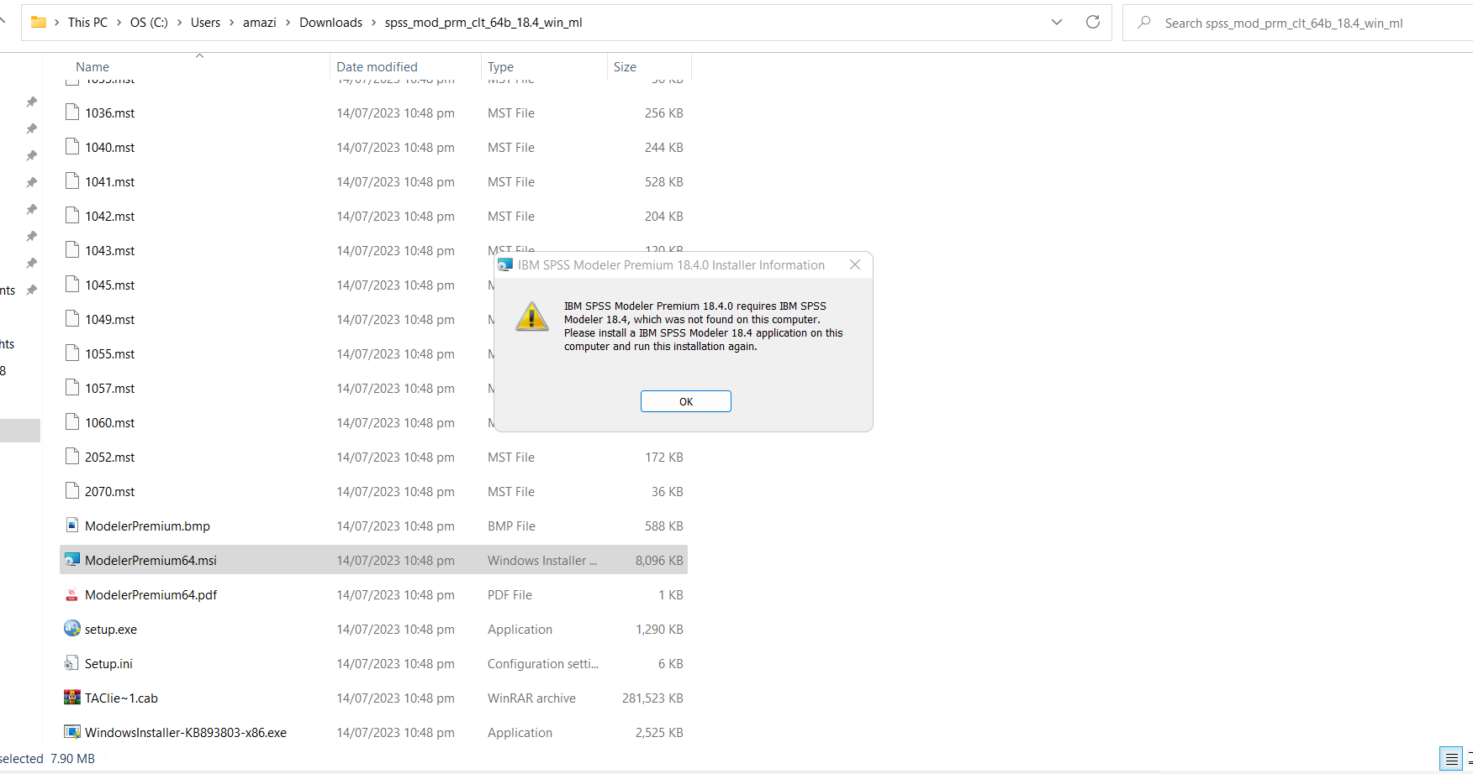

Please select the package indicated for **Mac**.

SPSS Modeler might show issues with the license when running in the environment of your device. In this case, please follow the below links to resolve the problem: [https://www.ibm.com/support/pages/launching-spss-modeler-1822-will-result-no-](https://www.ibm.com/support/pages/launching-spss-modeler-1822-will-result-no-licenses-found-ibm-spss-modeler-182-errcode2-subcode12) [licenses-found-ibm-spss-modeler-182-errcode2-subcode12](https://www.ibm.com/support/pages/launching-spss-modeler-1822-will-result-no-licenses-found-ibm-spss-modeler-182-errcode2-subcode12)

Or:

[https://www.ibm.com/support/pages/error-7001-symptom-18-there-no-license-ibm-](https://www.ibm.com/support/pages/error-7001-symptom-18-there-no-license-ibm-spss-statistics-authorized-user) [spss-statistics-authorized-user](https://www.ibm.com/support/pages/error-7001-symptom-18-there-no-license-ibm-spss-statistics-authorized-user)

If you have trouble with installing software, please email [jizhi.liu@auckland.ac.nz](mailto:jizhi.liu@auckland.ac.nz) or come to your lab session/tutor office hours for help with troubleshooting.

1. **MySQL (Optional)**
   1. Server: Go to <https://dev.mysql.com/downloads/mysql/>- Download (Windows or macOS) and Install
   2. Workbench: Go to <https://dev.mysql.com/downloads/workbench/>- Download (Windows or macOS) and Install
2. **Anaconda (Python)**
   1. Go to [https://www.anaconda.com/products/distribution#Downloads](https://www.anaconda.com/products/distribution) - Download (Windows or macOS) and Install
   2. Click through the installer. When you get to Advanced Installer Options, ensure that you select “Add Anaconda to my PATH environment variable” and “Register Anaconda as my default Python”.
   3. Open Anaconda Navigator and Install Spyder
3. **Weka**
   1. Go to <https://waikato.github.io/weka-wiki/downloading_weka/#stable-version>-

Download (Windows or macOS) and Install

* 1. You will need to install Java if not present already.

1. **Kettle & Spoon**

Go to <https://sourceforge.net/projects/pentaho/>- Click “Pentaho Community Edition can now be downloaded from <https://www.hitachivantara.com/en-us/products/pentaho-platform/data-integration-analytics/pentaho-community-edition.html>” to choose Pentaho Data Integration (Base Install).

Scroll down to access the installation guides for Windows and Linux.

1. **Tableau**
   1. Go to <https://www.tableau.com/academic/students#form>- Register with UoA email and Verify
   2. Click on link in email to Download (Windows or macOS) and Install
2. **Git**
   1. Go to <https://git-scm.com/downloads>- Download (Windows or macOS) and Install
   2. Note that free GitHub repositories are public. If you’d like a private repository, you can apply for a premium account: <https://education.github.com/pack>
3. **Amazon Web Services (AWS)**
   1. After Week 2, you will receive an email to get access to AWS Learner Labs. Sign up

and login as prompted.

* 1. Then, follow the instructions in the AWS Academy Learner Lab Guide document. Start from the sub-heading “Using/Reviewing a Students Account”.
  2. When you can see your AWS console, confirm your region.
  3. Note:
     1. Do not input your credit card details anywhere during sign up. It is not necessary to complete your assignments. You will not be reimbursed for any expenditure on AWS. This is all you need to do before the labs.
     2. Please do not click End Lab. If you end it, you will not be able to restart it and you will not have access to AWS or any of your files. All your work will be lost. Also, it is your responsibility to take regular backups of your work (using GitHub or something similar). GitHub comes preinstalled on your AWS instance.
     3. Please speak to your tutors if you have any questions.

1. **PuTTY**
   1. Go to <https://www.putty.org/>- Download for Windows
   2. Note: macOS users will need built-in SSH
2. **Azure ML (Optional)**
   1. Go to <https://azure.microsoft.com/en-us/free/students/>- Click Start Free and enroll with your UoA email. Please avoid providing credit card information at any step.
   2. Go to <https://portal.azure.com/>- Login and select ‘Azure Machine Learning’
   3. Additional documentation is available here: [https://azure.microsoft.com/en- us/services/machine-learning/#documentation](https://azure.microsoft.com/en-us/services/machine-learning/#documentation)
3. **SQL Server (Optional - Windows only)**
   1. Go to <https://www.microsoft.com/en-us/sql-server/sql-server-downloads>and download SQL Server Developer or Express edition and install.
   2. Go to [https://docs.microsoft.com/en-us/sql/ssms/download-sql-server- management-studio-ssms](https://docs.microsoft.com/en-us/sql/ssms/download-sql-server-management-studio-ssms) and download SQL Server Management Studio (SSMS) and install. Once completed, open and connect to SQL Server instance.
   3. Go to [https://docs.microsoft.com/en-us/sql/ssdt/download-sql-server-data-tools- ssdt](https://docs.microsoft.com/en-us/sql/ssdt/download-sql-server-data-tools-ssdt) and follow instructions to download and install SQL Server Data Tools (SSDT) as part of Visual Studio.
4. **Power BI (Optional - Windows only)**
   1. Go to <https://powerbi.microsoft.com/en-us/desktop/>- Download for Windows and Install
5. **Windows on macOS (with Intel chip)**
   1. To check your chip configuration, click on the Apple Menu > About This Mac > Overview. On this page you will see “Chip”. If it says something similar to “Apple M1”, then do not try to follow the instructions below.
   2. Those of you that are using MacBook’s without the M1 chip will need to install a Windows environment before you are able to install Windows software (such as Power BI). Note that you will need at least 8GB of RAM on your machine.
   3. To install Windows, go to <https://www.virtualbox.org/wiki/Downloads>- Download VirtualBox and Install
   4. Go to <https://portal.azure.com/>- register with your UoA email.
   5. Click Software and search for Windows 10 Education. Click Download to begin downloading an ISO file. Note the View Key button which you will need later to activate Windows.
   6. Feel free to follow this YouTube video: [https://www.youtube.com/watch?v=kF- 8JijHMEU,](https://www.youtube.com/watch?v=kF-8JijHMEU) otherwise follow the instructions below.
      1. Open VirtualBox, click New and type in a name.
      2. Select Microsoft Windows as Type, and Windows 10 (64-bit) as the version. Click Continue.
      3. Allocate (at maximum) half the machines total RAM. Click Next.
      4. Select Create a virtual hard disk now. Continue with the default settings, until you reach the File location and size screen. Allocate at least 32 GB of hard disk space. Click Create.
      5. On completion, right click the newly created virtual machine and click Settings. Then click Storage, select the icon with Empty written next to it, and click the CD icon on the right of the screen. Then click Choose a virtual optical disk file. Locate the downloaded ISO file, click open and click OK.
      6. Finally, click on the virtual machine and click Start in the top toolbar. Go through the Windows 10 setup as required. Type in your Windows 10 key when prompted.
      7. Note: Make sure to shut down the VM correctly after using it and take regular backups of your data.
   7. Note: If you have a Mac with M1 chip, you have the following options:
      1. Use a Windows laptop for Microsoft related software
      2. Loan a Windows laptop from the university
      3. Use a lab computer for your tutorials, assignments and projects
      4. Inform your course coordinator for further assistance.